I analyzed data of in-game purchases by players which the total players were 576 as per my analyzing I found out that:

* **Most of the players were male. From 576 of all Player 484 were male**

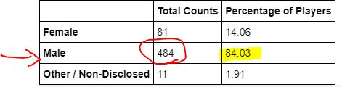

* **The 20-24 age group made most of the purchases in the game**

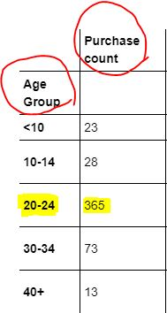

* **The age group that spends the most money was the 20-24 with $1,114.06 dollars as total purchase value**

